**Task 1:**

You are given the file AdventureWorksReturns.xlsx where the first row contains column headers like ProductID, ReturnDate, and Reason. However, these are not currently set as headers in Power BI. Promote the first row to act as column headers.

**Task 2:** Using AdventureWorksSales2015.xlsx, group the data by CustomerID to calculate:

* Total quantity of products ordered (OrderQty)
* Total number of orders placed (SalesOrderNumber count)

**Task 3:**

Load the AdventureWorksProductCategories.xlsx file. Transpose the table so that rows become columns and columns become rows. Understand how to switch rows to columns using Power Query.

**Task 4:**

Using AdventureWorksSales2017.xlsx, determine how many rows of data are available in the dataset using Power Query.Use the Count Rows feature.

**Task 1:**

You are given the file AdventureWorksReturns.xlsx where the first row contains column headers like ProductID, ReturnDate, and Reason. However, these are not currently set as headers in Power BI. Promote the first row to act as column headers.

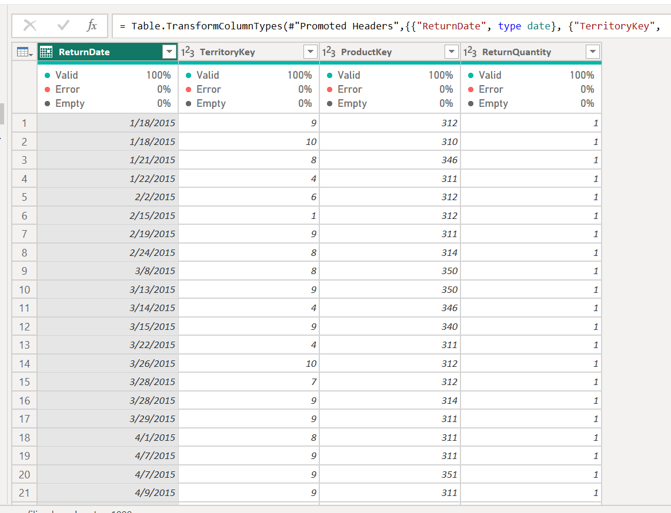

**Task 2:** Using AdventureWorksSales2015.xlsx, group the data by CustomerID to calculate:

* Total quantity of products ordered (OrderQty)
* Total number of orders placed (SalesOrderNumber count)

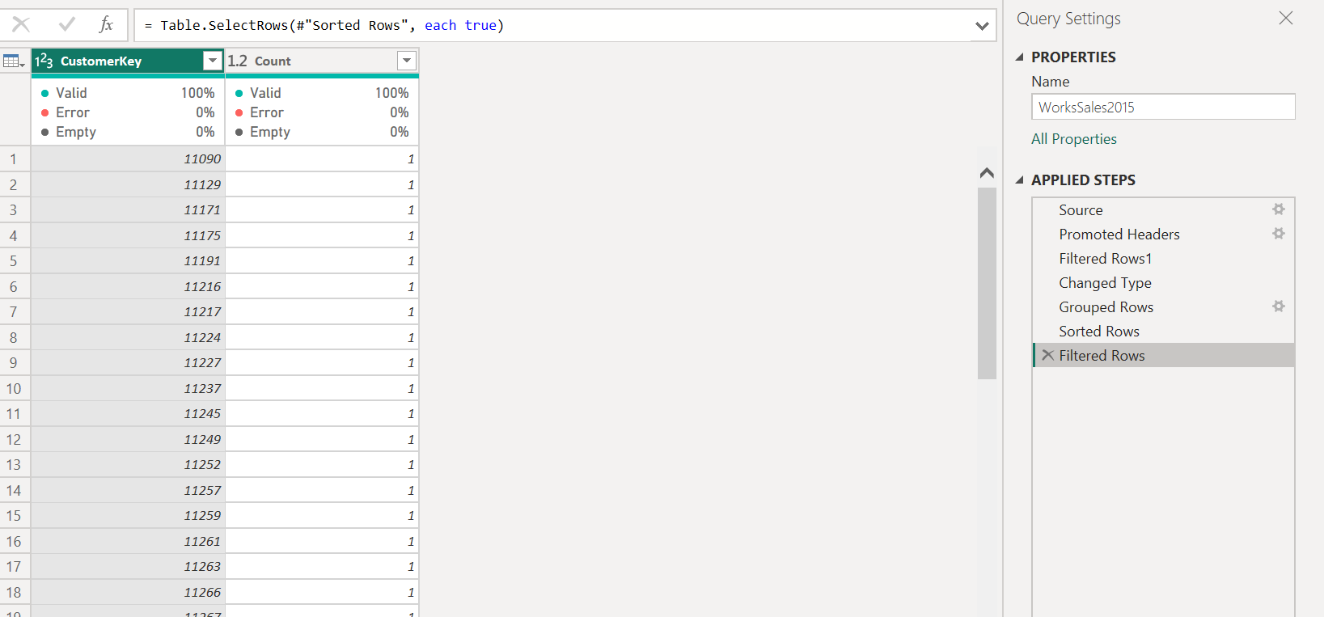

**Task 3:**

Load the AdventureWorksProductCategories.xlsx file. Transpose the table so that rows become columns and columns become rows. Understand how to switch rows to columns using Power Query.

**Task 4:**

Using AdventureWorksSales2017.xlsx, determine how many rows of data are available in the dataset using Power Query.Use the Count Rows feature.

